Victoria Junior College
Mathematics H1 (8864)
2012 Preliminary Examination

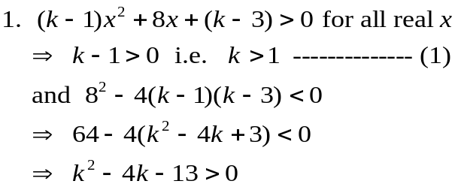  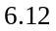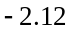  - and (2)   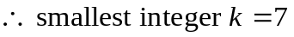 | 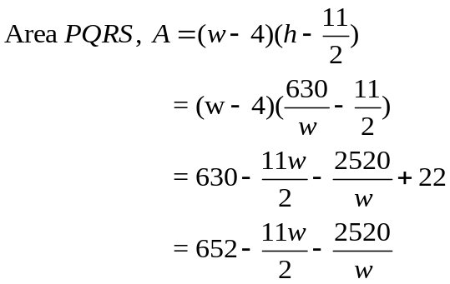  (ii)  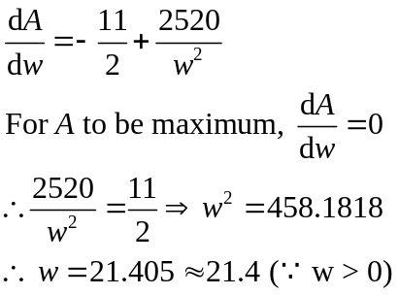  sign of 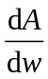  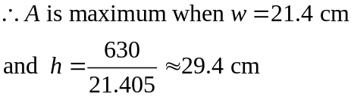  4.  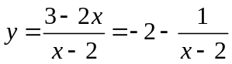  Equations of the asymptotes: 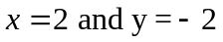  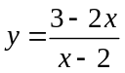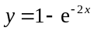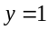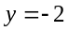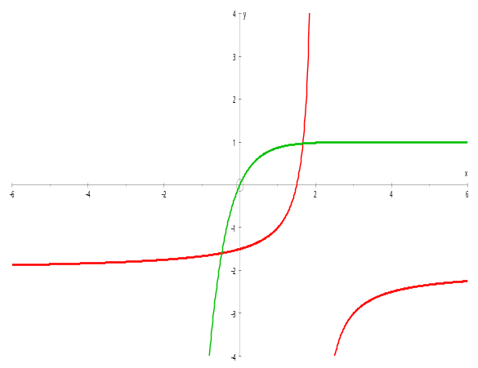  Area of the region enclosed between the 2 curves = 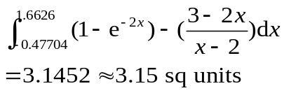  7.  (i)  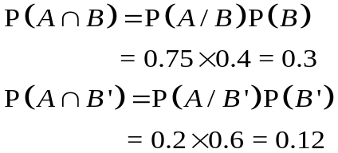  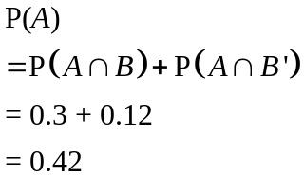  (ii)  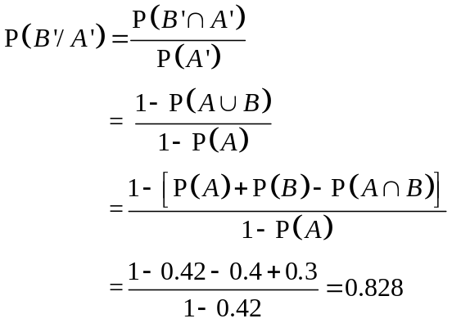  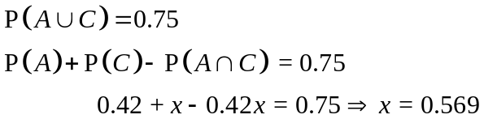  8. (i) Let be the number of staff members (out of 25) owning a car.  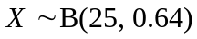  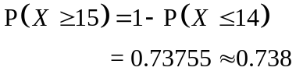  (ii) Let be the number of staff members owning a car in a sample of size.  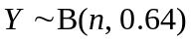  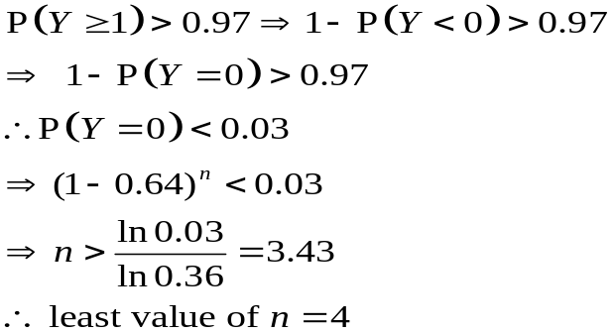  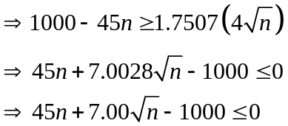  10. (i) Let   Then 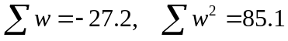  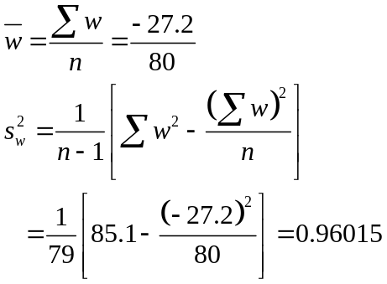  Now 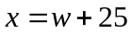  Let kg and kg be the respective mean mass and standard deviation of contents in a bag.  Unbiased estimate of the population mean, , is  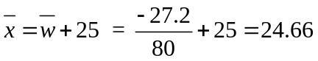  Unbiased estimate of the population variance, , is given by  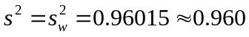  (ii)  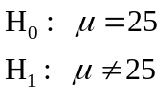  Level of significance: 1%  Test Statistic: Since is large, 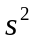is a good estimate of and CLT is used to approximate the distribution of 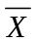to be normal.  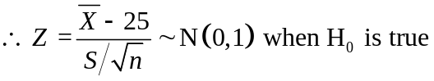  Rejection Region: 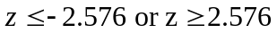  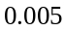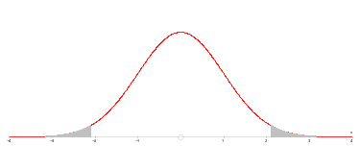  Computation: 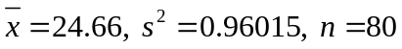  (ii) The product moment correlation coefficient,  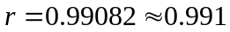  Since 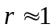and the points lie close to a straight line with positive gradient, this indicates that there is a strong positive linear relationship between the temperature of the shoulder of the tyre of the car and the speed of the car, that is, as the speed of the car increases, the temperature of the shoulder of its tyre tends to increase.  (iii) Equation of the regression line of on is  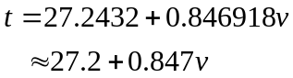  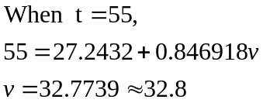  Since and scatter diagram shows a strong linear positive correlation and 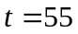lies within the data range of  the estimate is reliable.  (iv) No, a high correlation between speed and temperature does not necessarily imply that a higher speed would cause the temperature to increase. We cannot use the observed data to infer or conclude causal effect as there could be others factors in play.  The equation of the regression line of 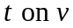is  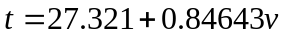  The regression line of passes through the point 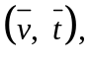  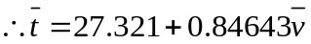  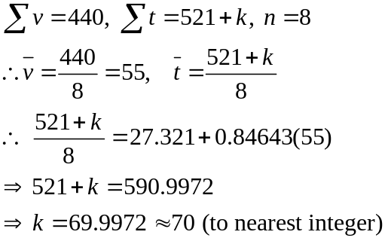
  From GC: 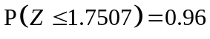  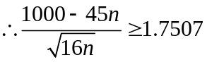 | 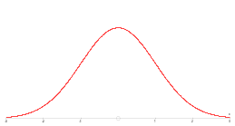
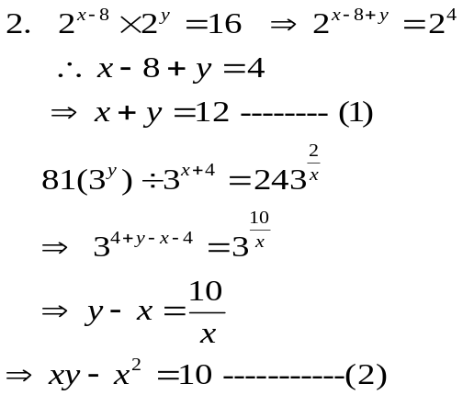
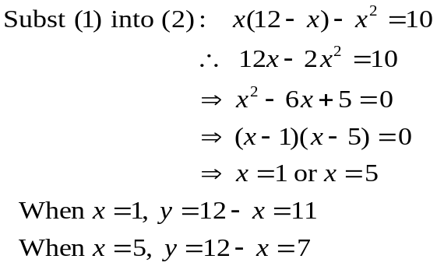
h cm
w cm
3cm
cm
2cm
2cm
A
B
C
D
P
Q
S
R
3. (i)
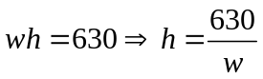

5(a)
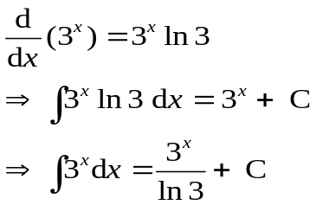
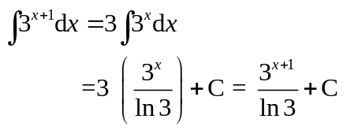
5(b)

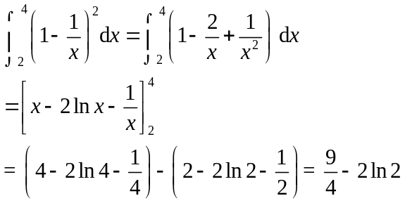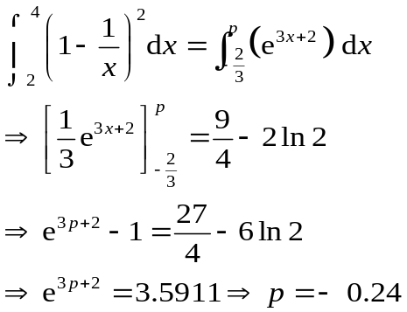

6. Let g be the mass of a yoghurt bar.
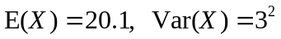
Let g be the mean mass of the bars.
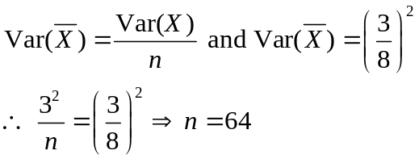
As >50, by CLT, 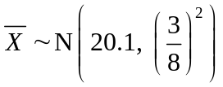 approx
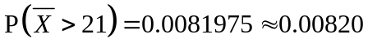
Since sample size (64) is large, by Central Limit Theorem, the distribution of the sample mean is approximately normally distributed. There is no assumption needed for the mass of a yoghurt bar to be normally distributed.

Alternatively, from GC:

 | 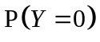 | Least value of = 4
3 | 0.0467 > 0.03
4 | 0.0168 < 0.03
5 | 0.00605

(iii) Let  be the number of staff members (out of 200) owning a car.
Since ,
We use normal approximation:
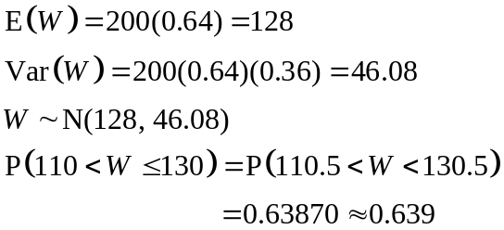

9. Let mm and mm be the thickness of a Statistics and a Calculus textbook respectively.
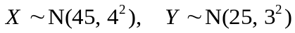
- (i) Let 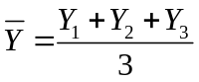be the average thickness of the 3 chosen Calculus textbooks.
- Then 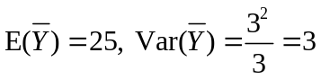
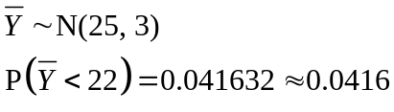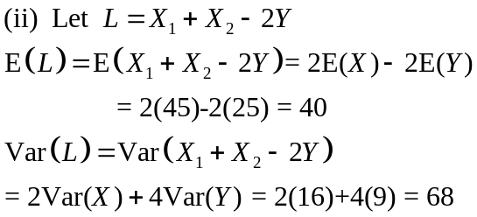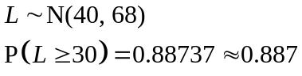

Let 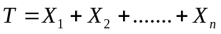be the total thickness
of the statistics textbooks.
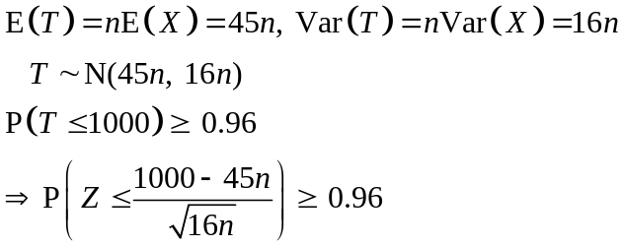
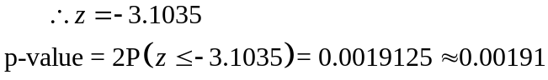
Conclusion: Since p-value = 0.00191< 0.01 (or 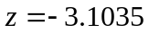<-2.576), 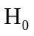 is rejected at 1% significance level. Hence there is sufficient evidence to conclude at the 1% significance level that the manufacturer’s claim is incorrect.

It is not necessary to assume the distribution of the mass of the contents of a bag, is normal as 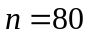 is large, 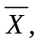the sample mean mass, is approximately normal by the application of the Central Limit Theorem.

(iii) ‘1% level of significance’ means there is a probability of 0.01 that the test will conclude the mean mass of the contents of a bag is not 25 kg when it is actually 25 kg.
(iv)
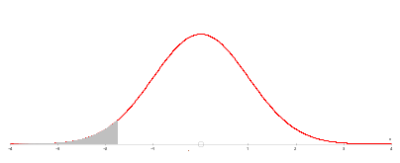

Rejection Region at the 1% significance level is
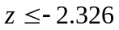
From (ii), calculated value of 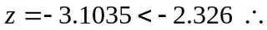 it is necessarily true to conclude at the 1% significance level that, on average, each bag contains less than 25 kg of salt.
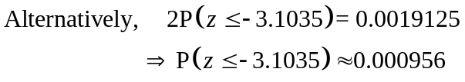
So 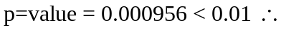 it is necessarily true to conclude at the 1% significance level that, on average, each bag contains less than 25 kg of salt.

11(i)
